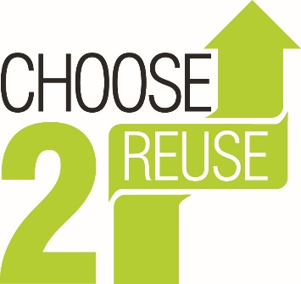

Choose2Reuse – Environmental Policy

Choose2Reuse is committed to adopting practices and behaviours that contribute to protection of the environment. Apart from the core business, which is concerned with minimising waste, the company strives to minimise other impacts on the environment through efficient use of energy; recycling of used materials such as papers, cans and bottles; supporting fair trade; and effectively managing waste in a way which is not harmful to the environment. It is also concerned to support the well-being of its employees and people living in the local community.
Before decisions are taken or actions implemented, every effort is made to assess potential impact on the quality of air, land and water in order to ensure that environmental impacts are kept to the absolute minimum.
All employees, partners and customers are reminded of the importance of considering environmental impacts in their day to day decision making, as well as the importance of well-being of themselves and others.
Choose2Reuse is committed to improving the quality of life for future generations through embedding environmental, economic and social considerations in day to day practices and decision making. It aims to improve its profitability and reduce costs through effective environmental management thereby ensuring the sustainability of the business. As part of this commitment to the principal of continual environmental improvement we have assessed our key environmental impacts as energy usage within the industrial units, the transport needed for the collection of items and waste generate during the sorting process.
In recognition of this, we have implemented the environmental management system. Our EMS focuses on:
• Complying with and where possible exceed the requirements of all relevant environmental legislation and compliance obligations both voluntary and mandatory
• Protecting the environment (including prevention of pollution)
• Assessing the environmental impacts of business operations.
• Reducing environmental impacts by recycling, increased energy efficiency, effective waste management and better water management
• Incorporating environmental factors into business decisions and practices
• Raising awareness, training and educating staff in environmental management
• Actively promote recycling internally to staff and externally to the local community, including the company’s customers
• Monitoring and improving environmental management and performance continually
• Minimising the production of waste and recycling waste which is produced where possible with an objective of working towards zero waste to landfill.
• Look for opportunities to reduce our energy & water use and associated carbon emissions, through investing in new technology and purchasing renewable energy.

The Environmental Policy will be communicated to all members of staff, made publicly available and reviewed annually and revised, as necessary.

Signature:

Date: 19.08.2021

